Here is the title of your paper as approved by the Editor
Name author 1^{a*} ORCID, Name author 2^{b} ORCID
ª Address of author 1. Email:
^{b} Address of author 2. Email:
* Corresponding author
Abstract
Here goes the abstract. For instance, one can write that this work intends to introduce a probabilistic approach for the crack propaga-tion analysis. It presents a methodology that is based on the distribution of the initial flaw size a0. Departing from fatigue test results for specific structural components, an estimation of the initial flaw distribution is obtained, and from this distribution it becomes possible to establish the appropriate initial flaw size for crack propagation analysis for the chosen statistical distribution, such as Weibull or Log-normal. The body of the abstract should be no more than 1,140 characters with spaces and 980 without spaces. Use a word processing program to type your abstract and rely on the word count function to verify the number of characters.
Keywords
Here goes the keywords chosen by the authors, e.g. fatigue, damage tolerance, Weibull distribution
Graphical Abstract
To enhance further the exposition of your paper, you are also welcome to submit in our LAJSS system a GRAPHICAL ABSTRACT. It is a single pictorial pdf file with the main findings of your article, and it will appear just below the normal Abstract so care should exercise to fit it in the opening page of your article. Graphical abstracts should be submitted as a separate file in the submission system by selecting “Graphical Abstract" from the drop-down list when uploading files. See full technical specifications below:
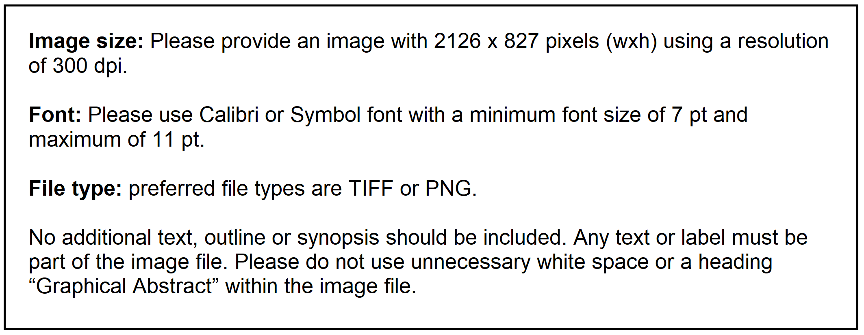

1 INTRODUCTION
This template is typeset using the format adopted by the Latin American Journal of Solids and Struc-tures. The fonts used can be download in the site and they are subject to the open source regulations. The fonts should be be installed in the folder used by the system to store this type of file.
Once the fonts are installed, you can typeset your paper. If your original paper was typeset with another font, it is now just a matter of chosen in the WORD2003 (or later) to change all the fonts to the one you downloaded in the system.
It is important to pay attention to the way you should refer to other articles and books. For instance, if you want to indicate a report you should write … the United States Air Force (USAF) pro-posed in MIL-E-83444 Rule (1974), deterministic values for the initial flaw size … You can see in the References section how it was typeset.
To refer to articles, like in … this concept was introduced after the works of Molent et al. (2006) … see in the references how it was typeset. For articles with one or two authors, please cite both surnames, like in Jones and Wierzbicki (1987). Refer to books as in Jones (2011) and to theses, like in Oshiro (2010). See the references again.

2 FIGURES
Please draw your figures using software of good quality. This will make your paper to look better and the readers will be more attracted to it. To refer to figure just use … according to Figure 1 … or something similar. You do not need to cross-reference your figures but, of course, this helps you in case you need to add or remove some, due to the requirements of the editor. See Figure 1 below and observe the font size and other details, like bold face in the word Figure, the full stop at the end and centered caption.
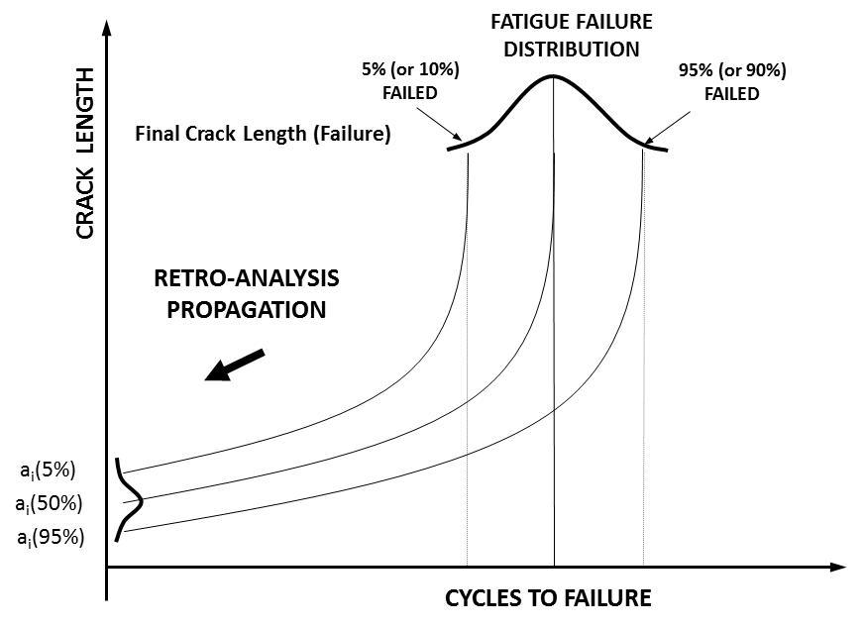
Figure 1 Schematic representation of inverse crack propagation analysis.

2.1 A sub-section
Note that, while the section was typeset in font size 11 and in upper case, the sub-section is typed in lower case and in font size 10.5. You do not need to worry much to these details if you use this template directly.
We take the chance to add an equation to this article, like … The Weibull distribution with two parameters (Montgomery and Runger, 1999) is given by the following equation
(1)
Note in the above equation that it has a number right ragged and that it was editable using MathType. This is most important for the typeset of your paper. All the symbols and equations must be edited using MathType. The reason is that you can change the math fonts to have a Latex look, which is the way they should appear in the final version of your paper. To do so, typeset your equa-tion and in MathType go to Preferences, Equation Preferences, Load from file, and chose TeX Look. From now on your equations will have a smart look.

3 RESULTS
We do not intend to guide the way you want to write your paper, but a section RESULTS is nearly always present in all the papers, despite of having different names. We quote now Figure 2, fol-lowed by Table 1, where you should pay attention to the various format features.
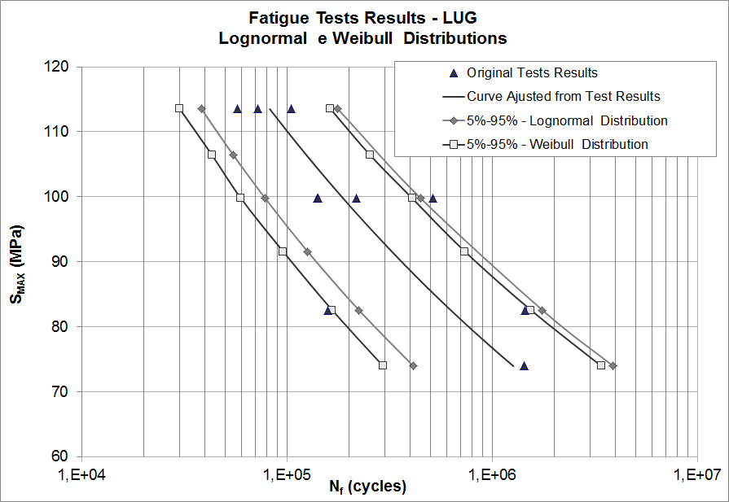
Figure 2: Application 1 (lug analysis) – S-N curve with the results of Weibull and Log-normal distribution
Table 1 This is an example of table. Note that there are no vertical lines, but variants of this model will be accepted. Note that the fonts are size 9 and that the top and bottom lines are doubled. The light gray shadow helps in the elegance and clarity.
Non corrected model
Scale | 1 | 1/2 | 1/4 | 1/100
final rotation (o) | 15.35o | 14.01o | 12.78o | 8.30o
end of the first phase (s) | 1.026E-4 | 9.362E-5 | 8.540E-5 | 7.555E-5
end of the second phase (s) | 4.870E-4 | 4.189E-4 | 3.604E-4 | 2.955E-4
final acceleration (m/s2) | 126680 | 147290 | 171210 | 208820
final strain rate (s-1) | 302.55 | 321.38 | 341.02 | 368.14
final stress (MPa) | 507.48 | 509.03 | 685.85 | 836.50
Corrected model
Scale | 1 | 1/2 | 1/4 | 1/100
velocity factor | 1 | 1,0801 | 1,1665 | 1,2915
final acceleration (m/s2) | 126680 | 126680 | 126680 | 126680
final strain rate (s-1) | 302.55 | 302.55 | 302.55 | 302.55
final stress (MPa) | 507.48 | 507.48 | 507.48 | 507.48

4 CONCLUSION
This is an example of a conclusion section, which goes … The methodology presented in this paper leads to more quantitative information and therefore to more consistent data to be used as input for damage tolerance analysis. However, some points deserve attention and will be discussed in this section. These points will be separated in short topics, as follows.

Author’s Contribuitions: LAJSS endorses the CRediT taxonomy of contributor roles. A distinction is made between fourteen types of contributions. See the details and types of contributions on https://www.casrai.org/credit.html. Example: Conceptualization, JJ Smith and A Silva; Methodology, JJ Smith; Investigation, JJ Smith, MA Morais and A Silva; Writing - original draft, JJ Smith, MA Morais and A Silva; Writing - review & editing, JJ Smith; Funding acquisition, MA Morais and A Silva; Resources, MA Morais and A Silva; Supervision, JJ Smith.

Data Availability: To confirm data availability, inform one of the following information:
● No research data was used
● Research data is not available
● Research data is available in a repository
● Research data is only available upon request
● Research data is available in the body of the article

Editor: (Filled by: Journal Staff)

References
Jones, N. (2011). Structural Impact, Cambridge University Press.
Jones, N., Wierzbicki, T., (1987). Dynamic plastic failure of a free-free beam. International Journal of Impact Engineering 6:240–255.
MIL A-83444 (USAF) (1974). Military Specification – Aircraft Damage Tolerance Requirements.
Molent, L., Sun, Q., Green, A. (2006). Characterization of equivalent initial flaw sizes in 7050 aluminium alloy, J. Fatigue Fracture Engineering Material Structures 29: 916-37.
Montgomery, D.C. and Runger, G.C., (1999). Applied statistics and probability for engineers, John Wiley Sons (New York).
Oshiro, R. (2010). Scaling of impacted structures, Ph.D. Thesis (in Portuguese), University of Sao Paulo, Brazil.

